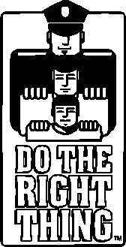**ATTENTION SCHOOLS...**

**HELP US RECOGNIZE AND REWARD**

**ALL DESERVING STUDENTS!**

**Every child nominated:**

* **Receives a t-shirt, a certificate and congratulatory letter, two tickets to a Miami Marlins game, a free pizza certificate from Papa John’s, and a DTRT bumper sticker!**

**Top 10 nominees:**

* **Receive at the monthly ceremony a mini tablet, plaque, t-shirt, gift certificates and passes to area attractions, bumper sticker, and a letter of congratulations from the MDCPS superintendent as well as members of the United States Congress!**

**Special Recognition Winners – best overall nominations for the month:**

* **Top elementary student receives a trip to Rapids Water Park for four!**
* **Top middle/high student receives a trip to Washington, D.C. with DTRT!**

**To nominate: nominate a student by submitting a four sentence nomination by logging on to** [**www.dotherightthinginc.org**](http://www.dotherightthinginc.org) **and clicking on the “Nominate Today” button on the homepage.**

**C:\Users\DTRT\AppData\Local\Microsoft\Windows\Temporary Internet Files\Content.IE5\E3PQSO3Z\MC900281970[1].wmf**

**Stay connected:**

**Like us on Facebook: Search Do The Right Thing of Miami, Inc.**

**Follow us on Instagram and Twitter: @DTRTMiami**