DO THE RIGHT THING BOOSTER CLUB
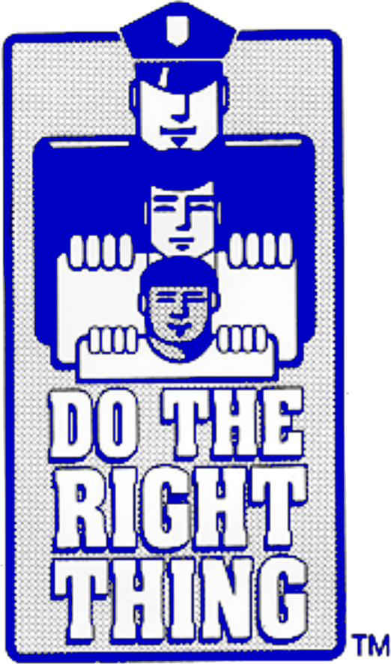
CHIEF BOOSTER PARTNER
$7,000 and up (or in-kind donation of equal value)
*Sponsorship of prizes for ninety (90) DTRT winners at nine monthly awards ceremonies with Chief of Police
*Company featured on DTRT poster/calendar of events distributed annually to all Miami-Dade County Public Schools plus School Board and City Commission-logo included at $5,000 cash or in-kind value or higher; otherwise company included in sponsor listing
*Company logo printed on 6,500 DTRT t-shirts for entire school year (nine monthly awards cycles). Logo size will be based on sponsorship level
*Company logo/website link featured on Do The Right Thing website
*Company’s sponsorship highlighted at nine monthly awards ceremonies
*Company sponsorship announced and promoted on DTRT Facebook group page, Instagram, and Twitter
*Company representative invited to present DTRT trip prizes at one monthly awards ceremony
*Company representative invited to end-of-the-year awards dinner and presented with an appreciation award

ASSISTANT CHIEF BOOSTER PARTNER
$6,000 (or in-kind donation of equal value)

* All of the above for a six-month sponsorship period

MAJOR BOOSTER PARTNER
$5,000 (or in-kind donation of equal value)

* All of the above for a five-month sponsorship period

COMMANDER BOOSTER PARTNER

$4,000 (or in-kind donation of equal value)

* All of the above for a four-month sponsorship period

CAPTAIN BOOSTER PARTNER

$3,000 (or in-kind donation of equal value)

* All of the above for a three-month sponsorship period

LIEUTENANT BOOSTER PARTNER

$2,000 (or in-kind donation of equal value)
* All of the above for a two-month sponsorship period

SERGEANT BOOSTER PARTNER

$1,000 (or in-kind donation of equal value)
*All of the above for a one-month sponsorship period

OFFICER BOOSTER PARTNER

$500 (or in-kind donation of equal value)
*Company listed on DTRT school poster/calendar of events distributed annually to all Miami-Dade County Public Schools plus School Board and City Commission
*Company logo/website link added to Do The Right Thing website if applicable
*Company representative invited to end-of-the-year awards dinner and presented with an appreciation award

K-9 BOOSTER PARTNER

$100 or less (or in-kind donation of equal value)
*Certificate of Appreciation from the Chief of Police

Not applicable to the Law Enforcement Partners Campaign

A COPY OF THE OFFICIAL REGISTRATION AND FINANCIAL INFORMATION MAY BE OBTAINED FROM THE DIVISION OF CONSUMER SERVICES BY CALLING TOLL-FREE (800-435-7352) WITHIN THE STATE. REGISTRATION DOES NOT IMPLY ENDORSEMENT, APPROVAL OR RECOMMENDATIONS BY THE STATE.

