August 2017

Dear Teacher:

For the 27th consecutive year, the Miami Police Department is proud to sponsor the Do The Right Thing Program. The program is designed to positively impact the youth of our area by publicly recognizing those who distinguish themselves through their behavior and/or accomplishments.

Each month, as many as 700 children from Miami-Dade County are nominated by police officers, the public, and teachers such as you for the Do The Right Thing Award on the basis of their exemplary behavior and attitude. Ten monthly finalists are named and receive plaques and other prizes at a ceremony at the Miami Police Department with the Chief of Police and are featured on the DTRT website www.dotherightthinginc.org. An overall monthly “Special Recognition” winner in middle or high school receives a trip to Washington, D.C. with other DTRT winners. An overall monthly “Special Recognition” winner in elementary school receives a trip to Rapids Water Park with his/her family and other DTRT winners. In order to reach as many children as possible and reinforce their positive behavior, ALL STUDENTS NOMINATED receive a certificate, a bumper sticker, a congratulatory letter from the City of Miami and Miami-Dade Schools chiefs of police, a free pizza from Papa John’s, and a Do The Right Thing T-shirt.

STEP 1: You MUST use our online nomination process by logging onto our website, clicking on the “Nominate Today” button on the homepage and completing the form.

STEP 2: Make sure your DTRT Coordinator is aware of who you nominated and how many per month so they can keep track. Please note that each school is limited to 15 nominations per month. Additionally, nominations must be specific and a minimum of four sentences.

We will notify your school’s DTRT Coordinator by email if you have a Top 10 winner. The “Special Recognition” winners are announced at our monthly awards ceremonies at police headquarters. Additionally, your school should receive the prizes for the remaining nominees by the 20th of the following month thru school mail (please be patient as they usually take about 2 weeks for delivery). For example, October nominees will receive their prizes on or before November 20th.

Thank you for your assistance in implementing the program and for helping your students continue to “do the right thing!”

Sincerely,

Jodi Atkison

Jodi Atkison
Executive Director
Do The Right Thing of Miami, Inc.

Board of Directors

Teresa Enriquez
President

Juanita Walker
Vice President

Marie-Jo Toussaint
Secretary

Christopher Rose
Treasurer

Rosalind Castle

Directors Emeritus

Daniel Alfonso
Rodolfo Llanes

Advisory Director

Trina Robinson/NBC 6

Founding Directors

Carol McCracken
Marzell Smith

Advisory Board

Dori Alvarez
Rona Brandell
Jaquelyn Calzadilla
Priscila Eidam
Jacqueline Gonzalez-Cuba
Commissioner Wifredo Gort
Commissioner Keon Hardemon
Donald March, Jr.
Ian Moffett
Lea Padron
Commissioner Ken Russell
Akua Scott
Commissioner Francis Suarez

Selection Committee

Cristina De Varona
Kenia Fallat
Sergio Guerrero
Richard Perez
Aileen Rodriguez

Staff

Jodi Atkison
Executive Director

Ariadna Espinosa
Program Coordinator

A not-for-profit organization dedicated to recognizing and rewarding our youth
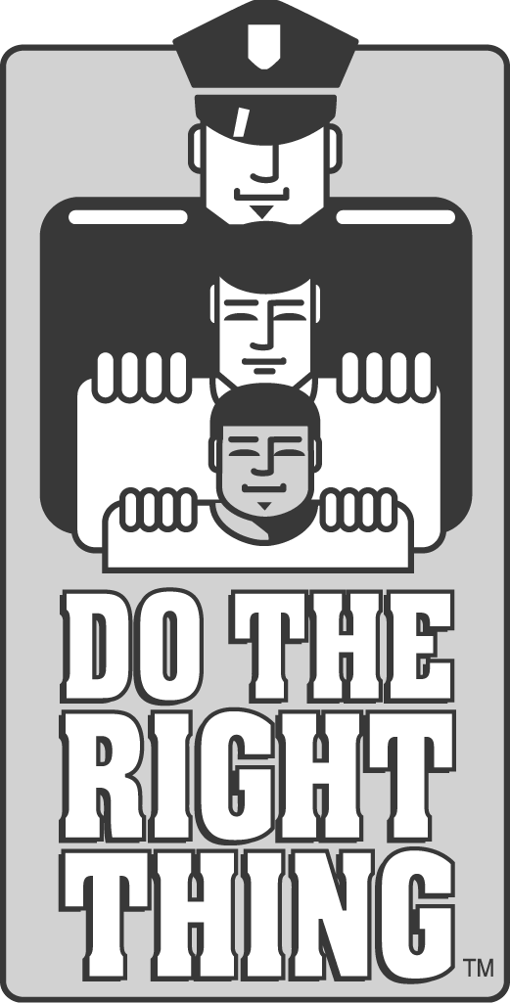
DO THE RIGHT THING OF MIAMI, INC.
c/o City of Miami Police Department
400 N.W. 2ND Avenue / Room 201-J / Miami, FL 33128
Phone:305-603-6957/Website:www.dotherightthinginc.org
Twitter/Instagram: @dtrtmiami

