August 2017

Dear Principal:

Now more than ever, we all need to work together to foster positive relationships between cops and kids. If your school is not already doing so, please consider participating in the Do The Right Thing Program (DTRT) which recognizes and rewards the positive accomplishments of your students in conjunction with local law enforcement. By simply designating a member of your staff to serve as the DTRT Coordinator for your school and having him/her encourage staff to nominate, your students will receive T-shirts and other incentives delivered directly to your school at no cost to you!

Each month, as many as 700 children from Miami-Dade County are nominated by teachers, counselors, parents, police officers, and the public for the Do The Right Thing Award on the basis of their exemplary behavior and attitude. Ten monthly finalists are named and an overall monthly “Special Recognition” winner in middle or high school receives a trip to Washington, D.C. with other DTRT winners. An overall monthly “Special Recognition” winner in elementary school receives a trip to Rapids Water Park with his/her family and other DTRT winners.

In order to reach as many children as possible and reinforce their positive behavior, EACH STUDENT NOMINATED FROM YOUR SCHOOL receives a certificate and a congratulatory letter from the City of Miami and Miami-Dade Schools chiefs of police, a free pizza from Papa John’s, a bumper sticker, and a Do The Right Thing T-shirt. All “Special Recognition” winners and Top 10 finalists receive plaques and other prizes at our monthly awards ceremonies at police headquarters. They are also featured on the DTRT website at www.dotherightthinginc.org.

Again, all you have to do is designate a counselor or other member of your staff to serve as your school’s coordinator. The coordinator is responsible for encouraging participation in our program at your school and MOST IMPORTANTLY, getting teachers and staff to nominate students. Please direct them to our website www.dotherightthinginc.org and have them fill out the DTRT Coordinator Registration Form found by clicking on the “Register (Schools Only)” button on the homepage. This will ensure that all future correspondence is directed to them.

We also encourage you to further recognize youngsters at your school for “doing the right thing” by acknowledging them within the school itself. Make space available on a central bulletin board to salute the monthly Do The Right Thing nominees and congratulate them during daily PA announcements. Have a Do The Right Thing Day each month and invite nominees to wear their T-shirts. Honor finalists selected from your school during school assemblies. Help us get our message across: “Good kids are newsworthy, positive behavior is noticed, and police officers care!”

If you have any questions, would like further information or want to share your ideas about the program, please feel free to call me at 305-603-6957 or e-mail us at dtrtmiami@aol.com.

Thank you for helping us to reach the youth of our community through your assistance with this program.

Sincerely,

Jodi Atkison

Jodi Atkison
Executive Director
Do The Right Thing of Miami, Inc.

Board of Directors

Teresa Enriquez
President

Juanita Walker
Vice President

Marie-Jo Toussaint
Secretary

Christopher Rose
Treasurer

Rosalind Castle

Directors Emeritus

Daniel Alfonso
Rodolfo Llanes

Advisory Director

Trina Robinson/NBC 6

Founding Directors

Carol McCracken
Marzell Smith

Advisory Board

Dori Alvarez
Rona Brandell
Jaquelyn Calzadilla
Priscila Eidam
Jacqueline Gonzalez-Cuba
Commissioner Wifredo Gort
Commissioner Keon Hardemon
Donald March, Jr.
Ian Moffett
Lea Padron
Commissioner Ken Russell
Akua Scott
Commissioner Francis Suarez

Selection Committee

Cristina De Varona
Kenia Fallat
Sergio Guerrero
Richard Perez
Aileen Rodriguez

Staff

Jodi Atkison
Executive Director

Ariadna Espinosa
Program Coordinator

A not-for-profit organization dedicated to recognizing and rewarding our youth
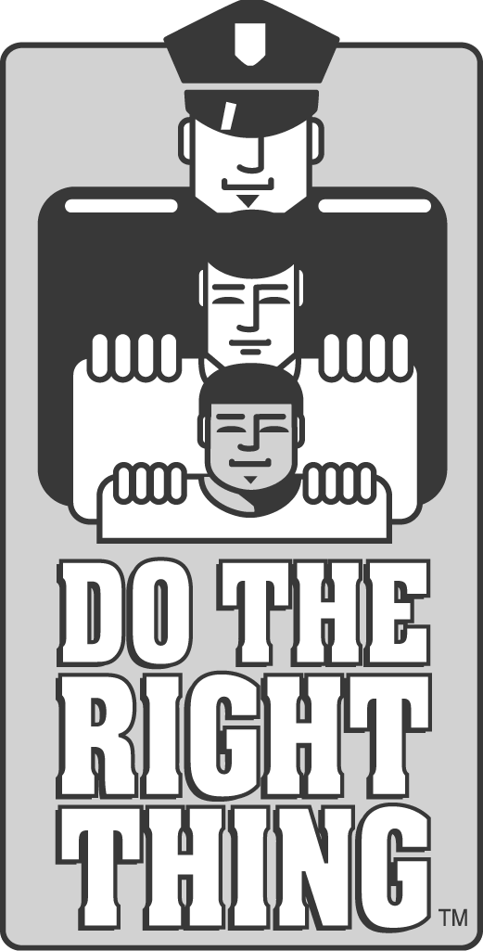
DO THE RIGHT THING OF MIAMI, INC.
c/o City of Miami Police Department
400 N.W. 2ND Avenue / Room 201-J / Miami, FL 33128
Phone:305-603-6957/Website:www.dotherightthinginc.org
Twitter/Instagram: @dtrtmiami

