August 2017

Dear Do The Right Thing Coordinator:

Welcome back! We hope you had a wonderful, restful summer. Please read this letter carefully.

The Do The Right Thing Program (DTRT), sponsored by the Miami Police Department, recognizes and rewards children for “doing the right thing.” Each month, as many as 700 children from Miami-Dade County are nominated by teachers, counselors, parents, police officers, and the public for the Do The Right Thing Award on the basis of their exemplary behavior and attitude. Ten monthly finalists are named and receive plaques and other prizes at a ceremony at the Miami Police Department with the Chief of Police. An overall monthly “Special Recognition” winner in middle or high school receives a trip to Washington, D.C. with other DTRT Special Recognition winners. An overall monthly “Special Recognition” winner in elementary school receives a trip to Rapids Water Park for four. All Top 10 winners are also featured on the DTRT website. In order to reach as many children as possible and reinforce their positive behavior, ALL STUDENTS NOMINATED receive a certificate and a congratulatory letter from the City of Miami and Miami-Dade Schools chiefs of police, a free pizza from Papa John’s, a bumper sticker, and a Do The Right Thing T-shirt delivered through school mail.

STEP 1: REGISTER AS DTRT COORDINATOR
Log on to our website www.dotherightthinginc.org and fill out the DTRT Coordinator Registration Form found by clicking on the “Register (Schools Only)” button on the homepage. All DTRT Coordinators must register every school year even if you’ve registered with us in previous years.

STEP 2: PROMOTE WITHIN YOUR SCHOOL
All materials needed to promote the program throughout your school are available on our website under the Awards Program/School Info tab. Please print, copy, or email and distribute as necessary to all school personnel. At the beginning of the school year, we will be mailing program information along with our 2017-2018 Do The Right Thing calendar/poster in brown tubes to the attention of Principal/DTRT Coordinator. Please check with your principal to obtain these materials. A poster will also be mailed to your attention once you register as DTRT Coordinator.

STEP 3: NOMINATE
You must use our online nomination process by logging onto our website, clicking on the “Nominate Today” button on the homepage and completing the nomination form. Nominations are required to be a minimum of 4 sentences.

STEP 4: TRACK YOUR NOMINATIONS
Each school is limited to 15 nominations per month and nominations are due by the 20th of each month.

STEP 5: STAY CONNECTED
Please log on our website www.dotherightthinginc.org and periodically check the “Latest News” and “Coordinator Corner” sections of the homepage for all updates. You can also join us on Facebook by searching for “Do The Right Thing of Miami, Inc.,” and follow us on Instagram and Twitter by searching for @dtrtmiami.

If your school has a Top 10 winner, you will be notified by email. Additionally, your school should receive the prizes for the remaining nominees by the 20th of the following month through school mail (please be patient as they usually take about 2 weeks for delivery). For example, October nominees will receive their prizes on or before November 20th.

If you have any questions, would like further information, or want to share your ideas about the program, please feel free to call 305-603-6957 or e-mail us at dtrtmiami@aol.com. Keep up the good work and we look forward to reading about your great kids this school year!

Sincerely,

Jodi Atkison

Jodi Atkison
Executive Director
Do The Right Thing of Miami, Inc.

Board of Directors

Teresa Enriquez
President

Juanita Walker
Vice President

Marie-Jo Toussaint
Secretary

Christopher Rose
Treasurer

Rosalind Castle

Directors Emeritus

Daniel Alfonso
Rodolfo Llanes

Advisory Director

Trina Robinson/NBC 6

Founding Directors

Carol McCracken
Marzell Smith

Advisory Board

Dori Alvarez
Rona Brandell
Jaquelyn Calzadilla
Priscila Eidam
Jacqueline Gonzalez-Cuba
Commissioner Wifredo Gort
Commissioner Keon Hardemon
Donald March, Jr.
Ian Moffett
Lea Padron
Commissioner Ken Russell
Akua Scott
Commissioner Francis Suarez

Selection Committee

Cristina De Varona
Kenia Fallat
Sergio Guerrero
Richard Perez
Aileen Rodriguez

Staff

Jodi Atkison
Executive Director

Ariadna Espinosa
Program Coordinator

A not-for-profit organization dedicated to recognizing and rewarding our youth
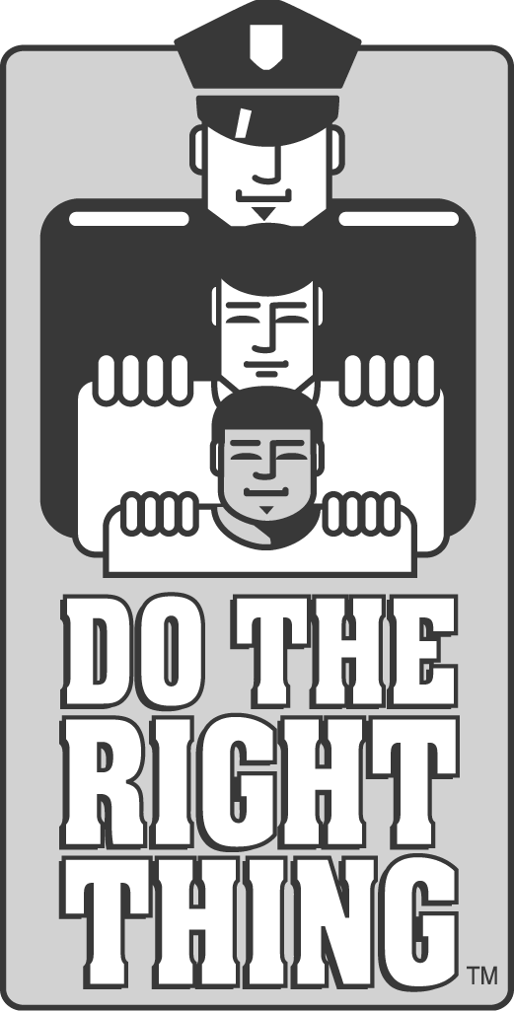
DO THE RIGHT THING OF MIAMI, INC.
c/o City of Miami Police Department
400 N.W. 2ND Avenue / Room 201-J / Miami, FL 33128
Phone:305-603-6957/Website:www.dotherightthinginc.org
Twitter/Instagram: @dtrtmiami

